JUnit - run only scheduled test run(s) with Universal agent of Automation Host

# Prerequisite:

* We use Junit project at <https://github.com/QASymphony/junit-sample>
* Java and Maven are installed on host machine
* Test project uses maven-surefire-plugin version 2.22.1 or later

# Create Universal agent with TestNG project

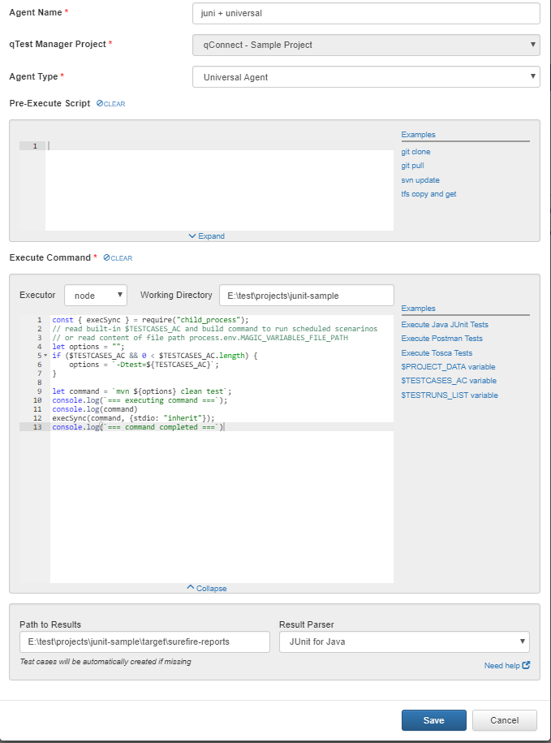

# How the example code works with the Universal agent

The code is copy here for your convenient



* In the first time, there is no schedule for the agent, to make the agent works user should click “run now” button, see figure below

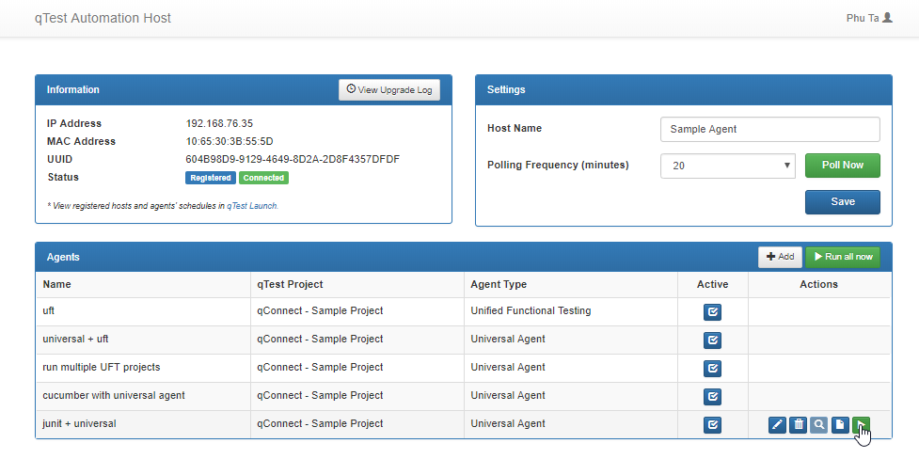

Figure Click run now to kick off Universal Agent

* A new UI is shown, with Last Set Magic Variables table shows 3 variables name: $PROJECT_DATA, $TESTCASES_AC, $TESTRUNS_LIST with empty value
* In the new UI, users can change their code in Pre-execute or Execute command editors, these changes only affect in this UI
* Click Execute button to kick off the agent

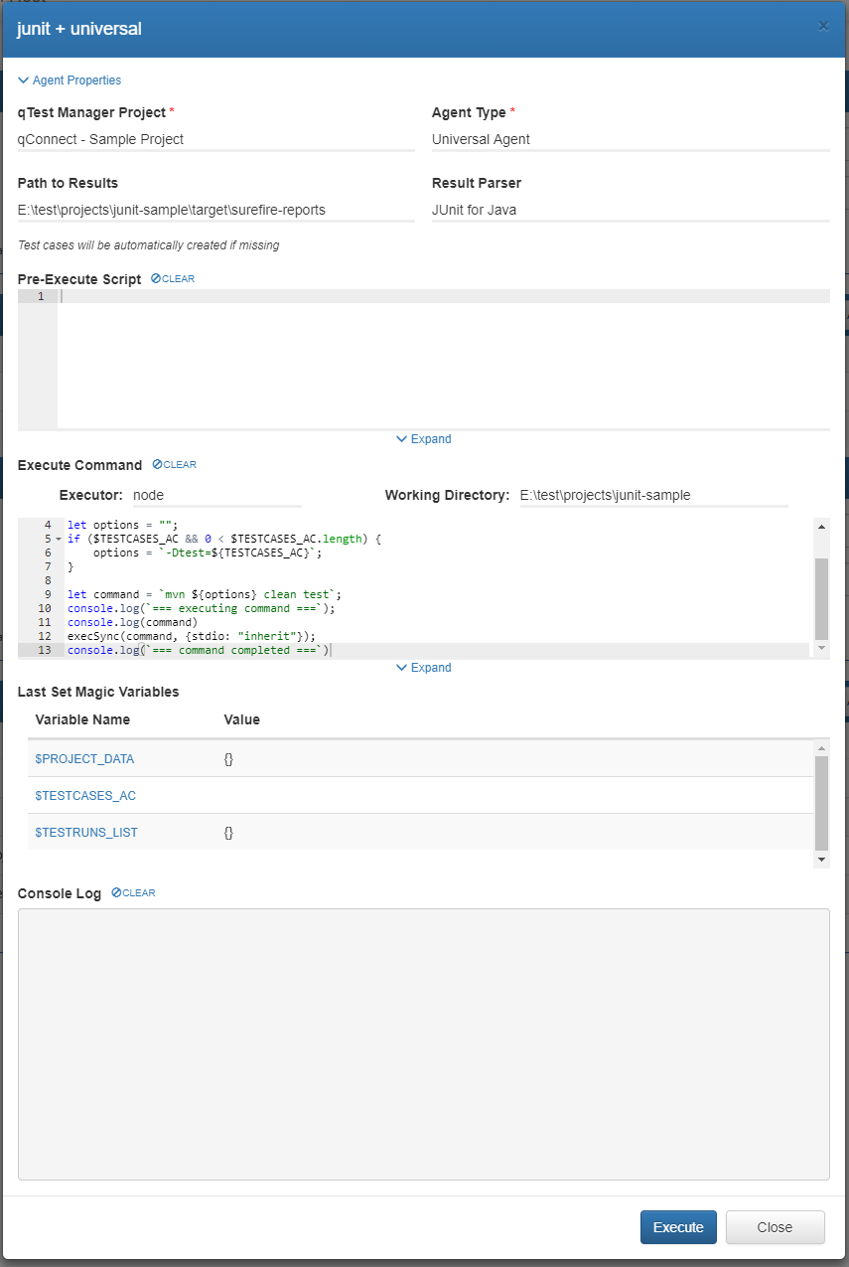

Figure Click Execute to run the Agent

* While running the log was shows in real time, this instutive to user to observe theirs code. Because there is no schedule test, the logic of the example code executes command like: **mvn clean test**, which indicates run all test in the test project

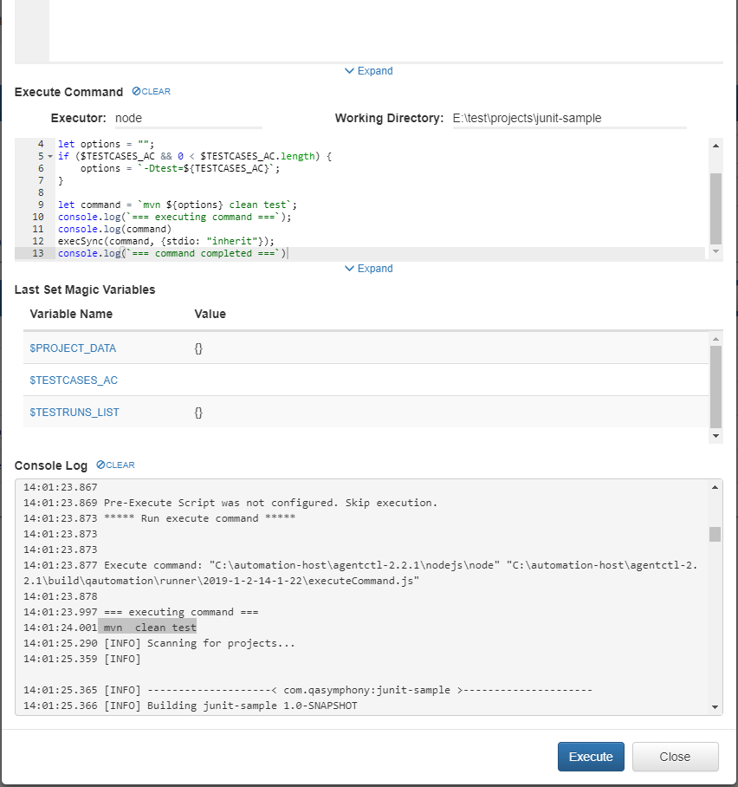

Figure Console Log shows real time log while agent is running

* After kick-off, now we have test runs submitted on qTest Manger, let schedule some test runs from qTest Launch

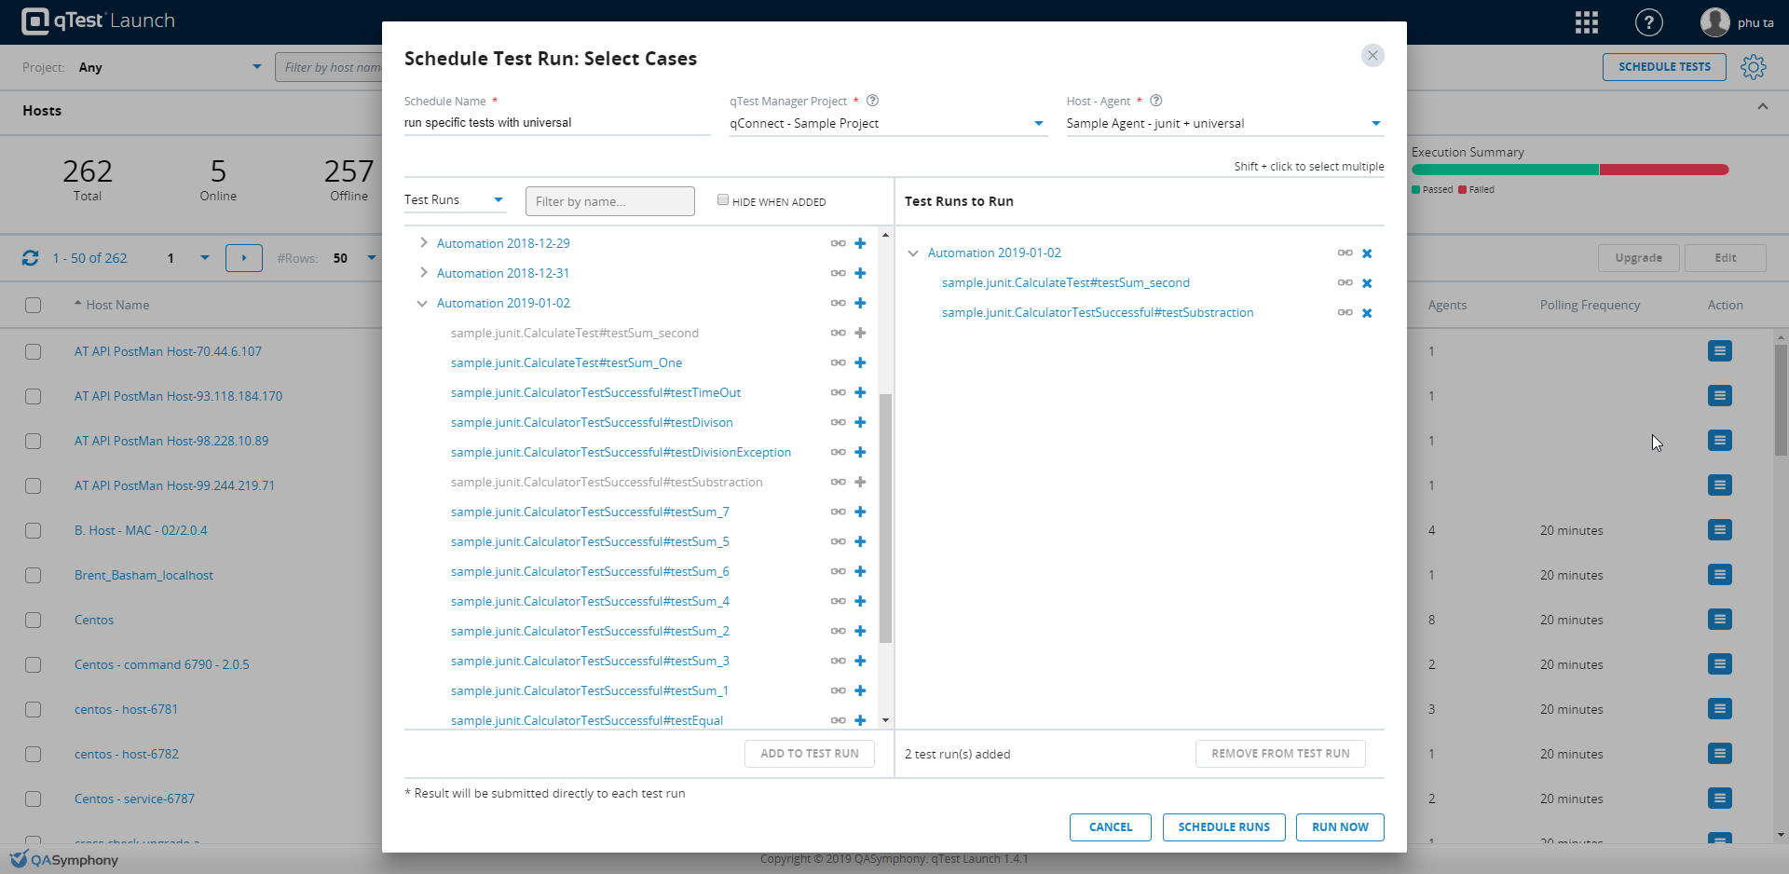

Figure Schedule some test runs from Launch

* UI below ,2 test runs will be run with the agent (created at beginning of this article)
* From the second times, the agent executes only test runs, which are scheduled, in this case only sample.junit.CalculateTest#testSum_second and sample.junit.CalculatorTestSuccessful#testSubstraction were executed
* The log of the agent will be like

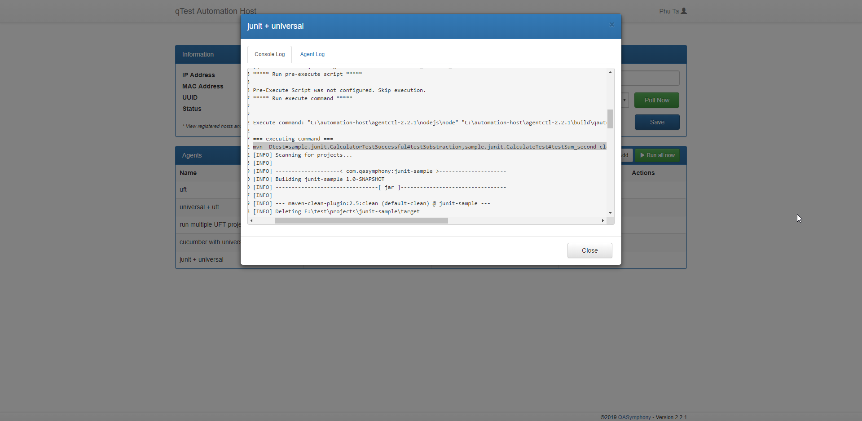

Figure Only selected test runs are executed